Zomato clone web site

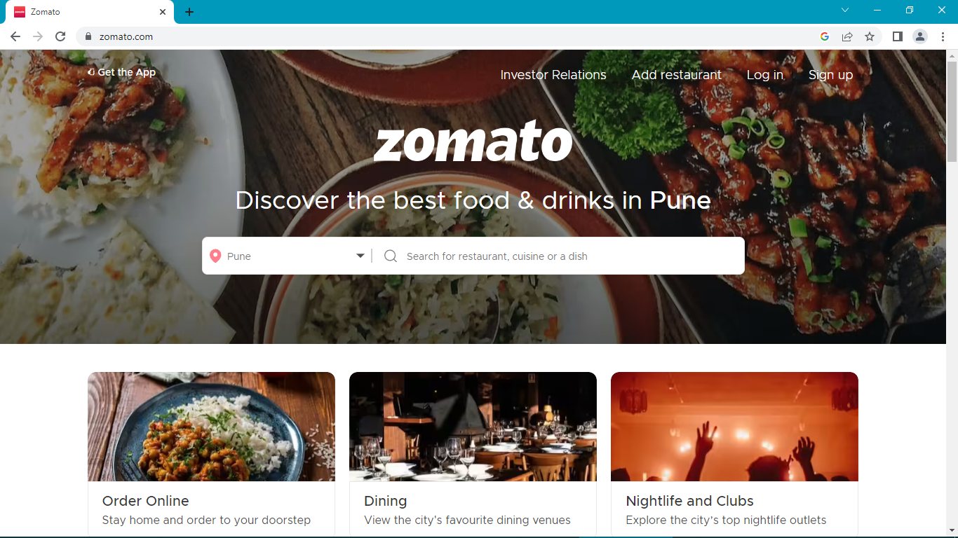

Project Name: Zomato Clone

Overview:

Customers use our platform to search and discover restaurants, read and write customer generated reviews and view and upload photos, order food delivery, book a table and make payments while dining-out at restaurants. Zomato provides information, menus and user-reviews of restaurants as well as food delivery options from partner restaurants in select cities.

Pages:

1.Homepage:

* Header section
* Zomato Logo, Add Location, Search Bar, sign in, sign up and Find restaurant
* Quick search

2.Filter page:

* Left Vertical section for filter
* Right side different varieties of food in city

3.Detail page:

* Images of food items and description
* Add to cart option
* Buy Now option

4.Payment gate

* Pay with Debit/Credit/ATM Cards
* Net banking
* Other UPI apps
* Cash on Delivery

Technologies Used in Project

**Front –End**

1.HTML

2.CSS

3.Bootstrap

4.React

**Dynamic:**

1.Javascript

**Database:**  
1.Mongodb

2.Json Data

**Code Compliers:**

1.Visual Studio Code

2.Git Bash

3.Google Chrome

4.Node Js

**Reference web sites**

<https://www.zomato.com>